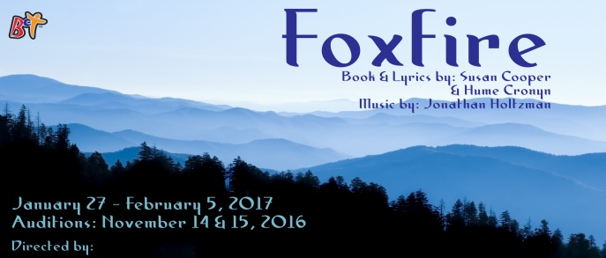
Beavercreek Community Theatre would like to extend a personal invitation to you to audition for their production of Foxfire.
Audition Dates: Monday November 14 and Tuesday November 15, 2016 at 7:00 pm at
Beavercreek Community Theatre
3868 Dayton-Xenia Road
Beavercreek, OH 45432
Production Dates: January 27, 28, 29 and February 3, 4, 5, 2017
Directed by: Saul Caplan
Music Coordinator: Mike Rousculp
Annie Nations, an indomitable Appalachian widow of 79, lives on her mountain farm with the acerbic ghost of her husband Hector. Her tranquility is threatened by a brash real estate developer who wants to turn her land into a vacation resort and by concern over her son Dillard, a country singer who has come home with two stranded children because his wife has run away. Annie’s battle to decide her future takes her through some funny, touching and magical flashbacks to her life with Hector.
Annie Nations: An elderly woman living on her family farm in the mountains of Georgia.
Hector Nations: Annie’s husband.
Prince Carpenter: A real estate man wanting to buy Annie’s farm. Looking for diversity in casting.
Holly Burrell: A young teacher and friend of the Nations family. Looking for diversity in casting.
Dillard Nations: Annie and Hector’s son, a traveling country singer and musician. Must be able to play guitar and sing. We are taking audition requests for this role now. If you are interested in this role, please contact us ASAP.
Doctor: The family doctor who delivered Dillard.
Also looking for 3-4 bluegrass/country musicians who will form a combo to play live during the show. If you are interested, please contact us ASAP.

Auditions will consist of readings from the script. You may deliver a prepared monologue if you wish (not required).

